**Practical – 2**

**Aim – Tribute Page**

**HTML Code:**

<html>

    <head>

        <title>

            Tribute Page

        </title>

    </head>

    <body>

        <center>

            <h1>

                <b>

                    <i>

                        Elon Musk

                    </i>

                </b>

            </h1>

        </center>

        <div style="display:flex;">

            <p style="flex-grow:1;">

                Elon Musk is a South African-born entrepreneur and inventor who

                has made significant contributions to a range of industries. He

                is most well-known for his work in the fields of aerospace and

                electric vehicles, where he has founded companies such as SpaceX

                and Tesla. Musk has been a key figure in the development of

                reusable rockets, making space travel more accessible and

                affordable. He has also been a driving force behind the push

                towards renewable energy and has been working to develop

                sustainable solutions for both transportation and energy

                production.

                <br>

                <br>

                In addition to his work in aerospace and electric vehicles, Elon

                Musk has also made significant contributions to the development

                of artificial intelligence and has been a vocal advocate for its

                safe and responsible use. He has founded companies such as

                Neuralink, which is focused on developing brain-machine

                interfaces, and OpenAI, which is dedicated to advancing AI in a

                responsible and ethical manner. Musk has also been a prominent

                critic of the dangers of unregulated AI development and has

                called for greater regulation and oversight.

                <br>

                <br>

                Elon Musk's entrepreneurial spirit and innovative ideas have

                made him one of the most influential figures in modern

                technology and business. He has been recognized with numerous

                awards and honors, including being named one of Time magazine's

                100 most influential people in the world. Despite his success,

                Musk has remained committed to using his wealth and influence to

                make a positive impact on the world. He has pledged to donate

                the majority of his fortune to philanthropic causes and has been

                actively involved in efforts to combat climate change and

                promote sustainable living.

                <br>

                <br>

                In 2002, Elon Musk founded SpaceX, a private space exploration

                company with the goal of reducing the cost of space travel and

                eventually colonizing Mars. Through SpaceX, Musk has

                accomplished several remarkable feats, such as being the first

                privately-funded company to send a spacecraft to the

                International Space Station and successfully landing and reusing

                Falcon 9 rockets. Musk's ultimate goal for SpaceX is to make

                humanity a multi-planetary species, with the eventual

                colonization of Mars.

                <br>

                <br>

                Despite his numerous successes, Musk has also faced criticism

                and controversy throughout his career. For example, he has been

                criticized for his management style and work culture at Tesla,

                which some employees have described as stressful and demanding.

                He has also faced criticism for some of his public statements,

                such as his skepticism about the severity of the COVID-19

                pandemic and his controversial comments on social media.

                <br>

                <br>

                In 2018, Musk made headlines when he tweeted that he was

                considering taking Tesla private at $420 per share, which caused

                the stock price to surge and resulted in an SEC investigation

                into his tweet. Musk ultimately settled with the SEC and agreed

                to step down as chairman of Tesla's board for three years. This

                incident highlighted the potential dangers of social media and

                the power of influential figures like Musk in the stock market.

            </p>

            <img

                src="https://t2.gstatic.com/licensed-image?q=tbn:ANd9GcSStEXQ52SE6txqvnwfAyOZ-dt6fkkBqzcir0RaZkoG54dYK7UByieR90Nb18ON4rdZ6VyDNVuQdk1kXik"

                alt="Elon Musk"

                style="margin-left: 20px;" width="340vw" height="512vw">

        </div>

        <p>

            In addition to his work with Tesla and SpaceX, Musk has also

            founded or co-founded several other companies, such as The

            Boring Company, which aims to create underground tunnels for

            transportation systems, and Neuralink, which aims to create

            brain-machine interfaces to enhance human capabilities. Musk's

            entrepreneurial spirit and passion for innovation has made him

            one of the most successful and influential entrepreneurs of our

            time.

            <br>

            <br>

            Despite his controversies and challenges, Musk continues to be a

            major figure in the tech and business world, with many people

            looking up to him as a visionary leader and innovator. He has

            been named one of Time's 100 most influential people and has

            received numerous awards and honors for his work, including the

            Royal Aeronautical Society Gold Medal and the Edison Achievement

            Award.

            <br>

            <br>

            Musk is also known for his philanthropy and commitment to social

            causes. He has pledged to donate most of his fortune to

            charitable causes and has supported initiatives such as

            renewable energy and education reform. He has also been vocal

            about the importance of addressing climate change and reducing

            carbon emissions, both through his work with Tesla and his

            advocacy for carbon taxes and other policies to combat climate

            change.

            <br>

            <br>

            Despite his wealth and success, Musk is known for his

            down-to-earth personality and willingness to engage with his

            fans and followers on social media. He frequently responds to

            questions and comments from his followers, and is known for his

            quirky sense of humor and candid responses. Musk's openness and

            approachability have helped him to connect with people from all

            walks of life and to inspire a new generation of entrepreneurs

            and innovators.

        </p>

        <footer>

            <center>

                <b>

                    <p>

                        Name: Nikhil Singhal

                    </p>

                    <p>

                        Roll No: 25106

                    </p>

                </b>

                <a href="http://www.linkedin.com/in/nikhilsinghal1704">

                    <p>

                        linkedin

                    </p>

                </a>

            </center>

        </footer>

    </body>

</html>

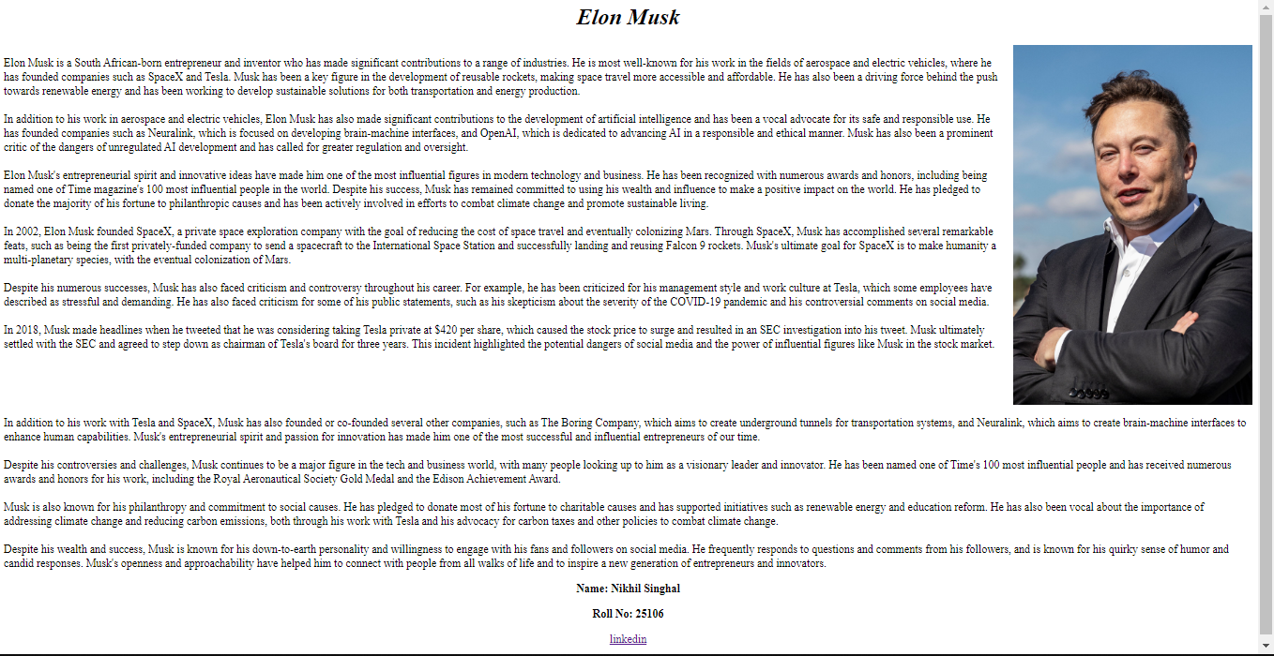**Screen Shot:**

**Practical - 3**

**Aim – Cat App**

**HTML Code:**

<html>

    <head>

        <title>Cats</title>

    </head>

    <body>

        <h1 style="text-align: center; color: blue;">Cats</h1>

        <p style="font-family: Arial; font-size: 18px;">Cats are small, furry

            animals that are often kept as pets. They are one of the most

            popular pets in the world. Cats have many different breeds, colors,

            and patterns. Some of the most common breeds are Persian, Siamese,

            Maine Coon, and Ragdoll.</p>

        <img

            src="https://upload.wikimedia.org/wikipedia/commons/thumb/3/3a/Cat03.jpg/1200px-Cat03.jpg"

            alt="A cat" width="300" height="200" style="display: block;

            margin-left: auto; margin-right: auto;">

        <p style="font-family: Arial; font-size: 18px;">Cats are carnivorous

            mammals that hunt and eat rodents, birds, and other small animals.

            They have sharp teeth and claws that help them catch their prey.

            Cats also have a keen sense of smell, hearing, and vision. They can

            see well in the dark and hear sounds that humans cannot.</p>

        <img

            src="https://upload.wikimedia.org/wikipedia/commons/thumb/b/bb/Kittyply_edit1.jpg/1200px-Kittyply_edit1.jpg"

            alt="A kitten" width="300" height="200" style="display: block;

            margin-left: auto; margin-right: auto;">

        <p style="font-family: Arial; font-size: 18px;">Cats are social animals

            that form bonds with their owners and other cats. They communicate

            with each other using vocalizations, body language, and scent

            marking. Cats can express various emotions, such as happiness,

            anger, fear, and curiosity. Cats also have a unique way of purring

            when they are content or relaxed.</p>

        <img

            src="https://upload.wikimedia.org/wikipedia/commons/thumb/6/64/Collage_of_Six_Cats-02.jpg/1200px-Collage_of_Six_Cats-02.jpg"

            alt="Six cats" width="300" height="200" style="display: block;

            margin-left: auto; margin-right: auto;">

        <footer>

            <center>

                <b>

                    <p>

                        Name: Nikhil Singhal

                    </p>

                    <p>

                        Roll No: 25106

                    </p>

                </b>

                <a href="http://www.linkedin.com/in/nikhilsinghal1704">

                    <p>

                        linkedin

                    </p>

                </a>

            </center>

        </footer>

    </body>

</html>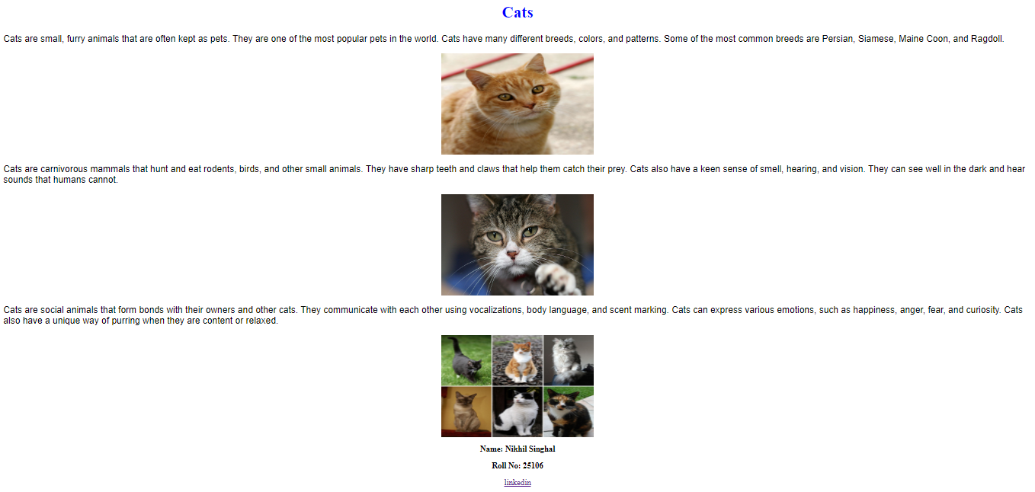

**Screen Shot:**

**Practical-1**

**Aim – Portfolio**

**HTML Code:**

<html>

    <head>

        <title>

            My Portfolio - Nikhil Singhal

        </title>

    </head>

    <body>

        <header>

            <center>

                <h1>Nikhil Singhal</h1>

            </center>

        </header>

        <h2>Hi there! Welcome to my portfolio</h2>

        <img

            src="profile.jpeg"

            alt="Six cats" width="300" height="400" style="display: block;

            margin-left: auto; margin-right: auto;">

        <h3>About Me</h3>

        <p>My name is Nikhil Singhal and I am a passionate web developer with

            experience in HTML, CSS, python-Flask. I enjoy building

            responsive and user-friendly websites that engage and delight users.</p>

        <h3>My Projects</h3>

        <ul>

            <li><a href="Tribute.html">Tribute Page</a></li>

            <li><a href="Catapp.html">Cat App</a></li>

            <li><a href="portfolio.html">Portfolio</a></li>

        </ul>

        <h3>Contact Me</h3>

        <p>Feel free to contact me if you have any questions or if you would

            like to work with me. You can reach me at

            <a href="mailto:nikhilsinghal1704@gmail.com">

                nikhilsinghal1704@gmail.com

            </a>

        </p>

        <footer>

            <center>

                <b>

                    <p>

                        Name: Nikhil Singhal

                    </p>

                    <p>

                        Roll No: 25106

                    </p>

                </b>

                <a href="http://www.linkedin.com/in/nikhilsinghal1704">

                    <p>

                        linkedin

                    </p>

                </a>

            </center>

        </footer>

    </body>

</html>

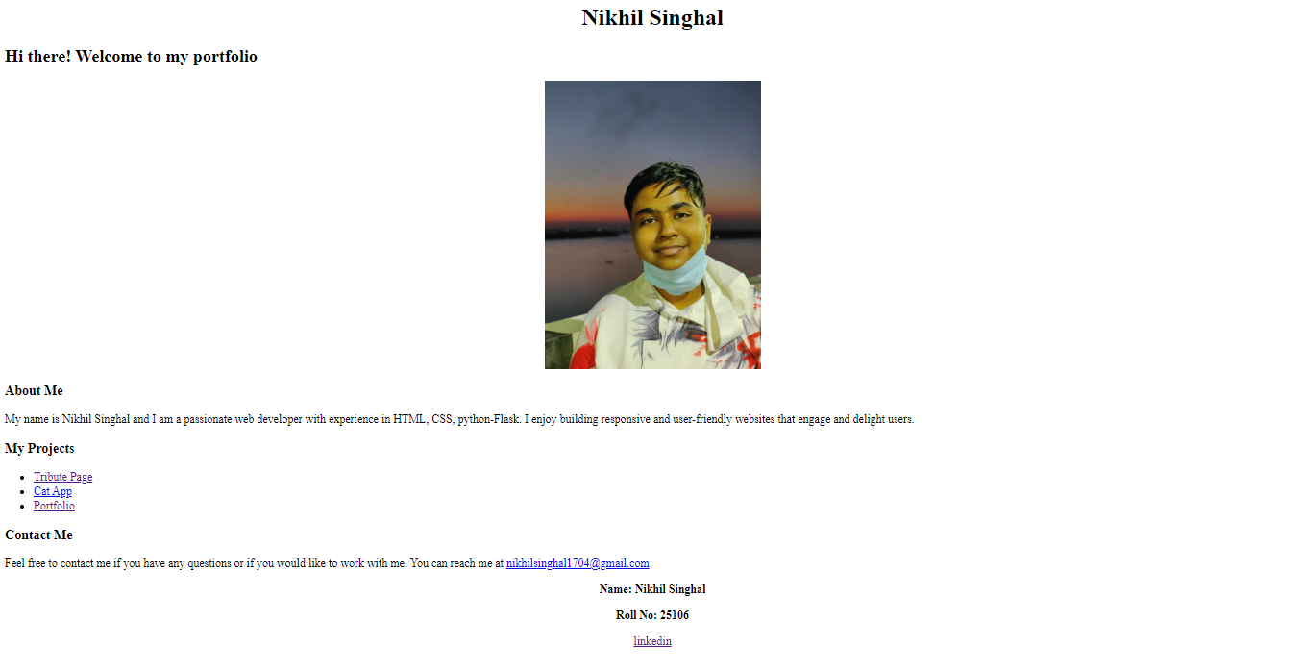**Screen Shot:**

**Practical-6**

**Aim – Calculator**

**HTML Code:**

<!DOCTYPE html>

<html lang="en">

<head>

    <meta charset="UTF-8">

    <meta http-equiv="X-UA-Compatible" content="IE=edge">

    <meta name="viewport" content="width=device-width, initial-scale=1.0">

    <title>Calculator with Rishabh Sir</title>

    <link rel="stylesheet" href="style.css">

</head>

<body>

    <div class="Heading">

        Calculator

    </div>

    <div class="container">

        <div class="display-container">

        </div>

        <div class="main-container">

            <div class="row">

                <div class="button">

                    AC

                </div>

                <div class="button">

                    Del

                </div>

                <div class="button">

                    .

                </div>

                <div class="button">

                    /

                </div>

            </div>

            <div class="row">

                <div class="button">

                    7

                </div>

                <div class="button">

                    8

                </div>

                <div class="button">

                    9

                </div>

                <div class="button">

                    *

                </div>

            </div>

            <div class="row">

                <div class="button">

                    4

                </div>

                <div class="button">

                    5

                </div>

                <div class="button">

                    6

                </div>

                <div class="button">

                    -

                </div>

            </div>

            <div class="row">

                <div class="button">

                    1

                </div>

                <div class="button">

                    2

                </div>

                <div class="button">

                    3

                </div>

                <div class="button">

                    +

                </div>

            </div>

            <div class="row">

                <div class="button-eq">

                    =

                </div>

            </div>

        </div>

    </div>

    <footer>

        <center>

            <b>

                <p>

                    Name: Nikhil Singhal

                </p>

                <p>

                    Roll No: 25106

                </p>

            </b>

            <a href="http://www.linkedin.com/in/nikhilsinghal1704">

                <p>

                    linkedin

                </p>

            </a>

        </center>

    </footer>

</body>

</html>

**CSS Code:**

body {

    background-color: rgb(26, 239, 239);

}

.Heading {

    display: flex;

    justify-content: center;

    color: white;

    font-size: 50px;

}

.container {

    display: flex;

    flex-direction: column;

    align-items: center;

    justify-content: center;

    margin: auto;

    border: solid 2px black;

    height: 700px;

    width: 700px;

    margin-top: 80px;

    background-color: rgb(56, 8, 230);

}

.container .display-container {

    border: solid 2px black;

    height: 100px;

    width: 650px;

    margin-bottom: 20px;

    cursor: text;

    background-color: rgb(233, 216, 20);

}

.container .main-container {

    border: solid 2px black;

    height: 510px;

    width: 650px;

    background-color: rgb(254, 238, 9);

}

.container .main-container .row {

    display: flex;

    font-size: 60px;

}

.container .main-container .row .button {

    border: solid 2px black;

    width: 132px;

    display: flex;

    justify-content: center;

    margin: 10px;

    margin-top: 17px;

    background-color: rgb(236, 59, 59);

}

.container .main-container .row .button:hover {

    cursor: pointer;

    background-color: rgb(226, 149, 149);

}

.container .main-container .row .button-eq {

    border: solid 2px black;

    width: 600px;

    display: flex;

    justify-content: center;

    margin: 10px;

    margin-top: 17px;

    background-color: rgb(19, 203, 228);

}

.container .main-container .row .button-eq:hover {

    cursor: pointer;

    background-color: rgb(134, 225, 237);

}

.container .display-container:hover {

    background-color: rgb(196, 194, 194);

}

.container .display-container:hover {

    background-color: rgb(235, 229, 156);

}

**Screen Shot:**

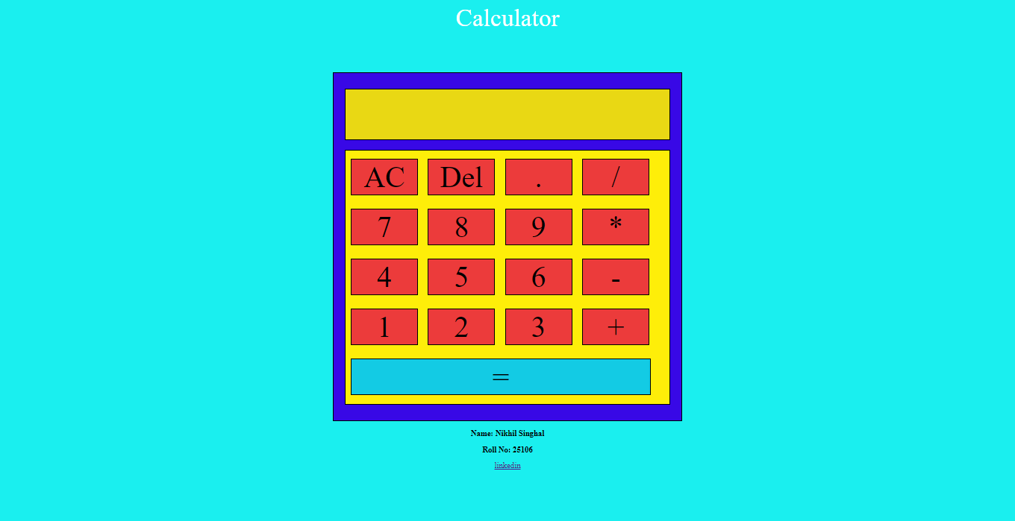

**Practical-8**

**Aim – Cafe-menu**

**HTML Code:**

<!DOCTYPE html>

<html lang="en">

  <head>

    <meta charset="UTF-8" />

    <meta http-equiv="X-UA-Compatible" content="IE=edge" />

    <meta name="viewport" content="width=device-width, initial-scale=1.0" />

    <title>Cafe Menu [Nikhil Singhal - 25106]</title>

    <link rel="stylesheet" href="style.css" />

  </head>

  <body>

    <div class="container">

      <div class="menu">

        <div class="head">

          <h1>CAMPER CAFE</h1>

          Est. 2020

        </div>

        <hr width="80%" color="brown" />

        <div class="coffee">

          Coffee

          <img src="assets/coffee-clipart-printable-18-2624923378.png" alt="" />

        </div>

        <div class="items">

          French Vanilla

          <div class="price">3.00</div>

        </div>

        <div class="items">

          Caramel Machhiato

          <div class="price">3.75</div>

        </div>

        <div class="items">

          Pumpkin Spice

          <div class="price">3.50</div>

        </div>

        <div class="items">

          Hazelnut

          <div class="price">4.00</div>

        </div>

        <div class="items">

          Mocha

          <div class="price">4.50</div>

        </div>

        <div class="coffee">

          Desserts

          <img src="assets/download_59077-4002001108.png" alt="" />

        </div>

        <div class="items">

          Donut

          <div class="price">1.50</div>

        </div>

        <div class="items">

          Cherry Pie

          <div class="price">2.75</div>

        </div>

        <div class="items">

          Cheesecake

          <div class="price">3.00</div>

        </div>

        <div class="items">

          Cinnamon Roll

          <div class="price">2.50</div>

        </div>

        <hr width="80%" color="brown" />

        <div class="cn">

          <a href="https://www.freecodecamp.org/">Vsit our Website</a>

          <br />

          123 Free Code Camp Drive

        </div>

      </div>

    </div>

  </body>

</html>

**CSS Code:**

body {

    background-color: rgb(26, 239, 239);

}

.Heading {

    display: flex;

    justify-content: center;

    color: white;

    font-size: 50px;

}

.container {

    display: flex;

    flex-direction: column;

    align-items: center;

    justify-content: center;

    margin: auto;

    border: solid 2px black;

    height: 700px;

    width: 700px;

    margin-top: 80px;

    background-color: rgb(56, 8, 230);

}

.container .display-container {

    border: solid 2px black;

    height: 100px;

    width: 650px;

    margin-bottom: 20px;

    cursor: text;

    background-color: rgb(233, 216, 20);

}

.container .main-container {

    border: solid 2px black;

    height: 510px;

    width: 650px;

    background-color: rgb(254, 238, 9);

}

.container .main-container .row {

    display: flex;

    font-size: 60px;

}

.container .main-container .row .button {

    border: solid 2px black;

    width: 132px;

    display: flex;

    justify-content: center;

    margin: 10px;

    margin-top: 17px;

    background-color: rgb(236, 59, 59);

}

.container .main-container .row .button:hover {

    cursor: pointer;

    background-color: rgb(226, 149, 149);

}

.container .main-container .row .button-eq {

    border: solid 2px black;

    width: 600px;

    display: flex;

    justify-content: center;

    margin: 10px;

    margin-top: 17px;

    background-color: rgb(19, 203, 228);

}

.container .main-container .row .button-eq:hover {

    cursor: pointer;

    background-color: rgb(134, 225, 237);

}

.container .display-container:hover {

    background-color: rgb(196, 194, 194);

}

.container .display-container:hover {

    background-color: rgb(235, 229, 156);

}

**Screen Shot:**

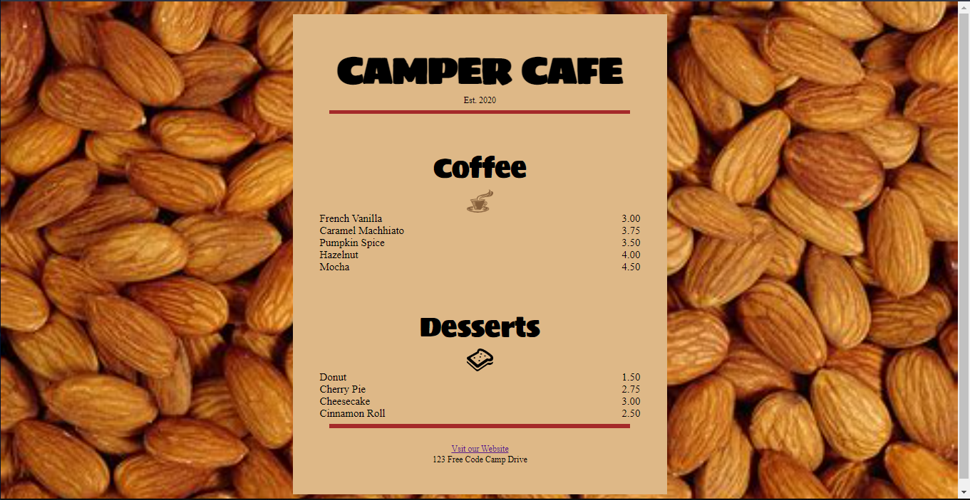

**Practical-7**

**Aim – Login-Page**

**HTML Code:**

<!DOCTYPE html>

<html lang="en">

  <head>

    <meta charset="UTF-8" />

    <meta http-equiv="X-UA-Compatible" content="IE=edge" />

    <meta name="viewport" content="width=device-width, initial-scale=1.0" />

    <title>Logn Page [ Nikhil CSE-1 25106 ]</title>

    <link rel="stylesheet" href="style.css" />

  </head>

  <body>

    <div class="container">

      <div class="login">

        <h1>USER LOGIN</h1>

        <div class="details">

          <div class="field">

            <label for="name"> Username </label>

            <br />

            <input id="name" />

            <label for="pass"> Password </label>

            <br />

            <input id="pass" />

            <button>Login</button>

            <div class="forgot">Forgot Password?</div>

          </div>

        </div>

      </div>

    </div>

  </body>

</html>

**CSS Code:**

body {

    background-color: #1dbb9c;

}

.container {

    height: 98vh;

    width: 100%;

    display: flex;

    flex-direction: column;

    justify-content: center;

    align-items: center;

}

.container .login {

    display: flex;

    flex-direction: column;

    justify-content: center;

    align-items: center

}

.container .login {

    background-color: white;

    height: 750px;

    width: 700px;

    margin: auto;

    border-radius: 20px;

}

.container .login>h1 {

    color: black;

    text-align: center;

    font-size: 52px;

    font-weight: 100;

}

.container .login .details {

    height: 550px;

    width: 610px;

    /* border: solid 2px black; */

}

.container .login .details .field {

    color: #1dbb9c;

    /* text-align: center; */

    font-weight: normal;

    font-size: 30px;

    padding: 45px;

    display: flex;

    flex-direction: column;

    justify-content: center;

}

.container .login .details .field input {

    border: solid 2px black;

    border-top: 0px;

    border-right: 0px;

    border-left: 0px;

    outline: none;

    font-size: 20px;

    font-weight: bold;

    width: 517px;

    height: 40px;

    margin-bottom: 60px;

}

.container .login .details .field input:hover,

.container .login .details .field input:focus {

    border: solid 2px #1dbb9c;

    border-top: 0px;

    border-right: 0px;

    border-left: 0px;

}

.container .login .details .field button {

    width: 300px;

    height: 65px;

    margin: auto;

    font-size: 35px;

    color: white;

    background-color: #1dbb9c;

    margin-bottom: 25px;

    cursor: pointer;

    border: 0px;

}

.container .login .details .field button:hover {

    background-color: #00ffcc;

}

.container .login .details .field .forgot {

    text-align: center;

    color: black;

}

.container .login .details .field .forgot:hover {

    cursor: pointer;

}

**Screen Shot:**

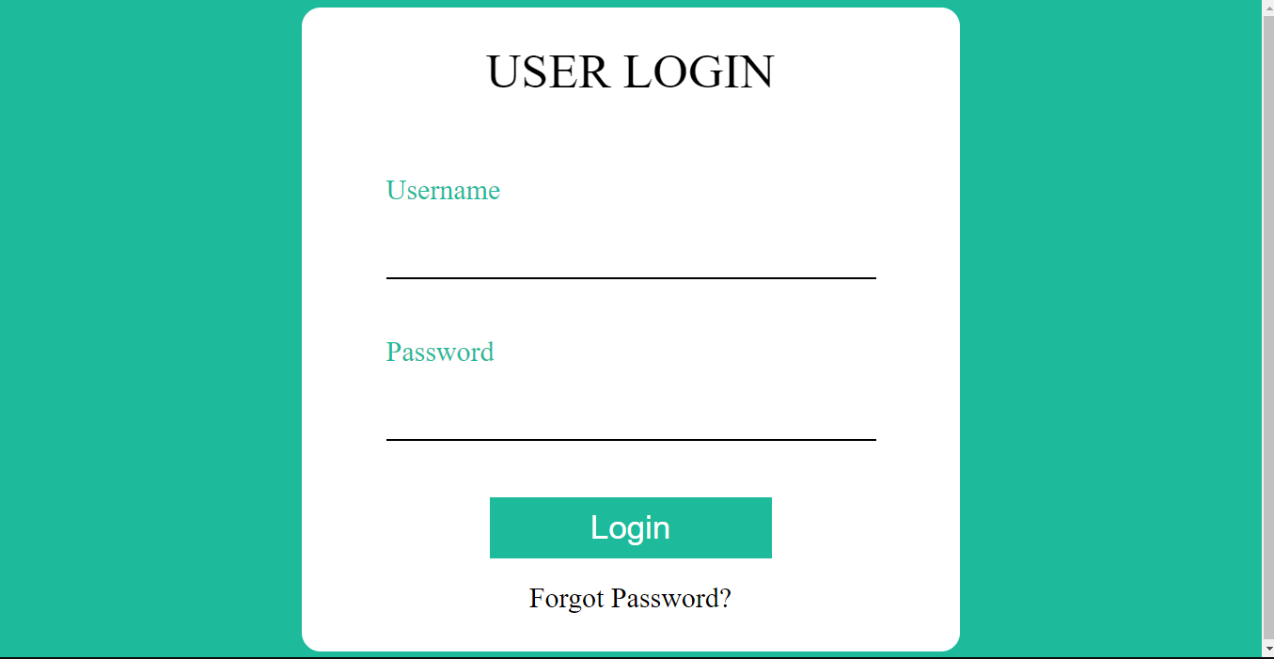

**Practical-5**

**Aim – YouTube Clone**

**HTML Code:**

<html lang="en">

  <head>

    <meta charset="UTF-8" />

    <meta http-equiv="X-UA-Compatible" content="IE=edge" />

    <meta name="viewport" content="width=device-width, initial-scale=1.0" />

    <!-- Material Icons -->

    <link href="https://fonts.googleapis.com/icon?family=Material+Icons"

      rel="stylesheet" />

    <!-- CSS File -->

    <link rel="stylesheet" href="style.css" />

    <title>Youtube Clone [Nikhil 25106]]</title>

  </head>

  <body>

    <header class="header">

      <div class="logo left">

        <i id="menu" class="material-icons">menu</i>

        <img

          src="https://www.freecodecamp.org/news/content/images/2022/01/yt-logo.png">

      </div>

      <div class="search center">

        <form action="">

          <input type="text" placeholder="Search" />

          <button><i class="material-icons">search</i></button>

        </form>

        <i class="material-icons mic">mic</i>

      </div>

      <div class="icons right">

        <i class="material-icons">videocam</i>

        <i class="material-icons">apps</i>

        <i class="material-icons">notifications</i>

        <img src="profile.jpeg" alt="Profile Image" height="24px" width="24px">

      </div>

    </header>

    <main>

      <div class=”side-bar”>

        <div class="nav">

          <a class="nav-link active">

            <i class="material-icons">home</i>

            <span>Home</span>

          </a>

          <a class="nav-link">

            <i class="material-icons">local_fire_department</i>

            <span>Trending</span>

          </a>

          <a class="nav-link">

            <i class="material-icons">subscriptions</i>

            <span>Subscriptions</span>

          </a>

          <a class="nav-link">

            <i class="material-icons">library_add_check</i>

            <span>Library</span>

          </a>

          <a class="nav-link">

            <i class="material-icons">history</i>

            <span>History</span>

          </a>

          <a class="nav-link">

            <i class="material-icons">play_arrow</i>

            <span>Your Videos</span>

          </a>

          <a class="nav-link">

            <i class="material-icons">watch_later</i>

            <span>Watch Later</span>

          </a>

          <a class="nav-link">

            <i class="material-icons">thumb_up</i>

            <span>Liked Videos</span>

          </a>

        </div>

        <hr>

      </div>

      <div class="content">

        <div class="videos">

          <div class="video">

            <div class="thumbnail">

              <img

                src="https://i.ytimg.com/vi/XcFOOfqfx3s/hq720.jpg"

                alt="" />

            </div>

            <div class="details">

              <div class="author">

                <img

                  src="https://yt3.googleusercontent.com/ytc/AGIKgqMRg4sLM1OyhxtKBu8jUVJ4_mbkYOd3mfl-zPVdXw=s176-c-k-c0x00ffffff-no-rj"

                  alt="" />

              </div>

              <div class="title">

                <h3>

                  Legend of BAGHDAD BATTERY, How Batteries Work

                </h3>

                <a href="https://www.youtube.com/@ElectroBOOM">

                  ElectroBOOM

                </a>

                <span> 2.5M Views • 3 Year Ago </span>

              </div>

            </div>

          </div>

          <div class="video">

            <div class="thumbnail">

              <img

                src="https://i.ytimg.com/vi/h6fcK_fRYaI/hq720.jpg"

                alt="" />

            </div>

            <div class="details">

              <div class="author">

                <img

                  src="https://yt3.googleusercontent.com/ytc/AGIKgqOibtncbyNaJVeUjVotNRl0r00hkiUfYEEv5XmNdw=s176-c-k-c0x00ffffff-no-rj"

                  alt="" />

              </div>

              <div class="title">

                <h3>

                  The Egg - A Short Story

                </h3>

                <a href=“https://www.youtube.com/@Kurzgesagt”>

                  Kurzgesagt – In a Nutshell

                </a>

                <span> 35M Views • 2 Year Ago </span>

              </div>

            </div>

          </div>

          <div class="video">

            <div class="thumbnail">

              <img

                src="https://i.ytimg.com/vi/kA0Ywk7sQLg/hq720.jpg"

                alt="" />

            </div>

            <div class="details">

              <div class="author">

                <img

                  src="https://yt3.googleusercontent.com/ytc/AGIKgqMRg4sLM1OyhxtKBu8jUVJ4_mbkYOd3mfl-zPVdXw=s176-c-k-c0x00ffffff-no-rj"

                  alt="" />

              </div>

              <div class="title">

                <h3>

                  Animation vs. League of Legends (official)

                </h3>

                <a href="https://www.youtube.com/@ElectroBOOM">

                  Alan Becker

                </a>

                <span> 113M Views • 4 Year Ago </span>

              </div>

            </div>

          </div>

        </div>

        <div class="videos">

          <div class="video">

            <div class="thumbnail">

              <img

                src="https://i.ytimg.com/vi/XcFOOfqfx3s/hq720.jpg"

                alt="" />

            </div>

            <div class="details">

              <div class="author">

                <img

                  src="https://yt3.googleusercontent.com/ytc/AGIKgqMRg4sLM1OyhxtKBu8jUVJ4_mbkYOd3mfl-zPVdXw=s176-c-k-c0x00ffffff-no-rj"

                  alt="" />

              </div>

              <div class="title">

                <h3>

                  Legend of BAGHDAD BATTERY, How Batteries Work

                </h3>

                <a href="https://www.youtube.com/@ElectroBOOM">

                  ElectroBOOM

                </a>

                <span> 2.5M Views • 3 Year Ago </span>

              </div>

            </div>

          </div>

          <div class="video">

            <div class="thumbnail">

              <img

                src="https://i.ytimg.com/vi/h6fcK_fRYaI/hq720.jpg"

                alt="" />

            </div>

            <div class="details">

              <div class="author">

                <img

                  src="https://yt3.googleusercontent.com/ytc/AGIKgqOibtncbyNaJVeUjVotNRl0r00hkiUfYEEv5XmNdw=s176-c-k-c0x00ffffff-no-rj"

                  alt="" />

              </div>

              <div class="title">

                <h3>

                  The Egg - A Short Story

                </h3>

                <a href=“https://www.youtube.com/@Kurzgesagt”>

                  Kurzgesagt – In a Nutshell

                </a>

                <span> 35M Views • 2 Year Ago </span>

              </div>

            </div>

          </div>

          <div class="video">

            <div class="thumbnail">

              <img

                src="https://i.ytimg.com/vi/kA0Ywk7sQLg/hq720.jpg"

                alt="" />

            </div>

            <div class="details">

              <div class="author">

                <img

                  src="https://yt3.googleusercontent.com/ytc/AGIKgqMRg4sLM1OyhxtKBu8jUVJ4_mbkYOd3mfl-zPVdXw=s176-c-k-c0x00ffffff-no-rj"

                  alt="" />

              </div>

              <div class="title">

                <h3>

                  Animation vs. League of Legends (official)

                </h3>

                <a href="https://www.youtube.com/@ElectroBOOM">

                  Alan Becker

                </a>

                <span> 113M Views • 4 Year Ago </span>

              </div>

            </div>

          </div>

        </div>

      </div>

    </main>

    <!-- Main Body Ends -->

  </body>

</html>

**CSS Code:**

@import url('https://fonts.googleapis.com/css2?family=Roboto:wght@300;400;700&display=swap');

* {

    margin: 0;

    padding: 0;

    box-sizing: border-box;

}

body {

    font-family: 'Roboto', sans-serif;

}

/* header section*/

.header {

    display: flex;

    justify-content: space-between;

    align-items: center;

    height: 60px;

    padding: 15px;

}

main {

    height: calc(100vh - 70px);

    display: flex;

    background-color: #f9f9f9;

}

/* Sidebar */

.side-bar {

    height: 100%;

    width: 17%;

    background-color: white;

    overflow-y: hidden;

}

@media (max-width: 768px) {

    .side-bar {

        display: none;

    }

}

.left {

    display: flex;

    align-items: center;

}

.left #menu {

    padding: 0 7px;

    cursor: pointer;

}

.search {

    display: flex;

}

.search form {

    display: flex;

    border: 1px solid #ddd;

    height: 45px;

}

.search input {

    width: 600px;

    padding: 10px;

    border: 0;

    height: 100%;

    border-radius: 2px 0 0 2px

}

input:focus {

    outline: none;

    border: 1px solid #ddd;

}

.search button {

    height: 100%;

    width: 60px;

    border: none;

}

.mic {

    margin-top: 10px;

}

.material-icons {

    color: rgb(100, 100, 100);

    padding: 0 7px;

    cursor: pointer;

}

.nav {

    width: 100%;

    display: flex;

    flex-direction: column;

    margin-bottom: 15px;

    margin-top: 15px;

}

.nav-link {

    display: flex;

    align-items: center;

    padding: 12px 25px;

}

.nav-link span {

    margin-left: 15px;

}

.nav-link:hover {

    background: #e5e5e5;

    cursor: pointer;

}

.active {

    background: #e5e5e5;

}

hr {

    height: 1px;

    background-color: #e5e5e5;

    border: none;

}

.content {

    background-color: #f9f9f9;

    width: 100%;

    height: 100%;

    padding: 15px 15px;

    border-top: 1px solid #ddd;

    overflow-y: scroll;

}

.videos {

    display: flex;

    flex-direction: row;

    justify-content: space-around;

    flex-wrap: wrap;

}

.video {

    width: 270px;

    margin-bottom: 30px;

}

.thumbnail {

    width: 100%;

    height: 170px;

}

.thumbnail img {

    object-fit: cover;

    height: 94%;

    width: 100%;

}

.author img {

    object-fit: cover;

    border-radius: 50%;

    height: 40px;

    width: 40px;

    margin-right: 10px;

}

.details {

    display: flex;

}

.title {

    display: flex;

    flex-direction: column;

}

.title h3 {

    color: rgb(3, 3, 3);

    line-height: 18px;

    font-size: 14px;

    margin-bottom: 6px;

}

.title a,

span {

    text-decoration: none;

    color: rgb(96, 96, 96);

    font-size: 12px;

}

@media (max-width: 768px) {

    .side-bar {

        display: none;

    }

    .search {

        display: none;

    }

}

@media (max-width: 900px) {

    .search input {

        width: 25rem;

    }

}

**Screen Shot:**

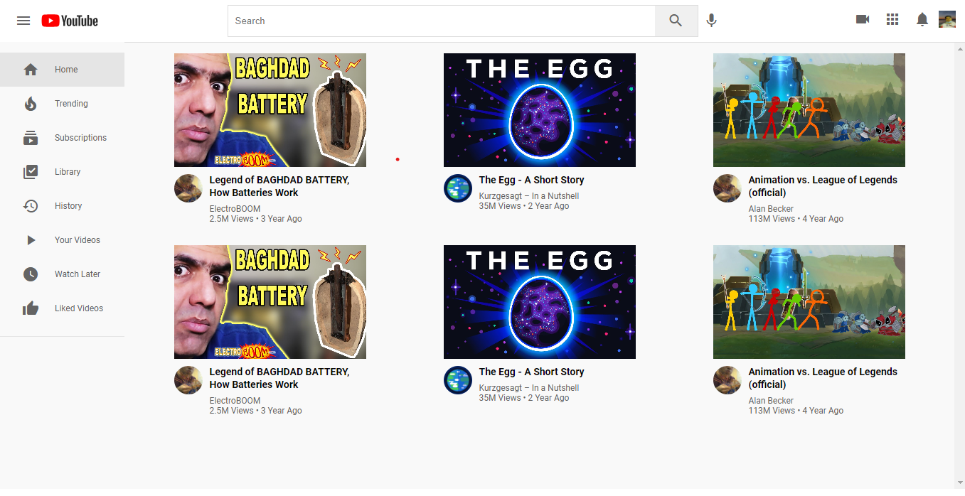

**Practical-4**

**Aim – Portfolio with CSS**

**HTML Code:**

<!DOCTYPE html>

<html lang="en">

  <head>

    <meta charset="UTF-8" />

    <meta http-equiv="X-UA-Compatible" content="IE=edge" />

    <meta name="viewport" content="width=device-width, initial-scale=1.0" />

    <title>My Portfolio</title>

    <link rel="stylesheet" type="text/css" href="style.css" />

  </head>

  <body>

    <div class="container">

      <header>

        <h1>Nikhil Singhal</h1>

      </header>

      <div class="Nikhil">

        <div class="Text">

          <h2>Hi there! Welcome to my portfolio</h2>

          <h3>About Me</h3>

          <p>

            My name is Nikhil Singhal and I am a passionate web developer with

            experience in HTML, CSS, python-Flask. I enjoy building responsive

            and user-friendly websites that engage and delight users.

          </p>

        </div>

        <img

          src="without CSS\profile.jpeg"

          alt="Profile Picture"

          width="300"

          height="400"

        />

      </div>

      <h3>My Projects</h3>

      <div class="project-images">

        <a href="without CSS\Tribute.html">

          <img src="without CSS/tribute.png" alt="Tribute Page" />

        </a>

        <a href="without CSS\Catapp.html">

          <img src="without CSS/Catapp.png" alt="Cat App" />

        </a>

        <a href="yt-clone/index.html">

          <img src="yt-clone/snap.png" alt="Portfolio" />

        </a>

      </div>

      <h3>Contact Me</h3>

      <p>

        Feel free to contact me if you have any questions or if you would like

        to work with me. You can reach me at

        <a href="mailto:nikhilsinghal1704@gmail.com"

          >nikhilsinghal1704@gmail.com</a

        >.

      </p>

      <footer>

        <b>

          <p>Name: Nikhil Singhal</p>

          <p>Roll No: 25106</p>

        </b>

        <a href="http://www.linkedin.com/in/nikhilsinghal1704"

          ><p>linkedin</p></a

        >

      </footer>

    </div>

  </body>

</html>

**CSS Code:**

/* Apply a reset to remove any default browser styles */

* {

  margin: 0;

  padding: 0;

  box-sizing: border-box;

}

/* Set a background color for the page */

body {

  background-color: #f8f8f8;

}

/* Center the container on the page */

.container {

  max-width: 800px;

  margin: 0 auto;

  padding: 20px;

}

/* Style the header and its child elements */

header {

  text-align: center;

  margin-bottom: 20px;

}

h1 {

  font-size: 36px;

  margin-bottom: 10px;

}

h2 {

  font-size: 24px;

  margin-bottom: 20px;

}

.Nikhil {

  overflow: auto;

  /* clear the float */

  display: flex;

  flex-direction: row;

  align-items: center;

  justify-content: space-between;

}

.text {

  display: flex;

  flex-direction: column;

  justify-content: flex-start;

  align-items: center;

  justify-content: space-between;

  height: 100%;

  width: 50%;

}

.Nikhil h2 {

  text-align: center;

}

.Nikhil img {

  float: right;

  margin: 0 0 1em 1em;

  /* add some space around the image */

  width: 40%;

  height: 100%;

}

/* Style the project images and their links */

.project-images {

  display: flex;

  flex-wrap: wrap;

  justify-content: space-between;

  align-items: center;

  margin-bottom: 10px;

}

.project-images img {

  height: 300px;

  width: 300px;

  object-fit: cover;

  margin: 5px;

}

.project-link {

  display: block;

  text-align: center;

  font-size: 18px;

  margin-bottom: 20px;

}

/* Style the footer and its child elements */

footer {

  text-align: center;

  margin-top: 20px;

  padding-top: 20px;

  border-top: 1px solid #ccc;

}

footer p {

  margin-bottom: 5px;

}

footer a {

  font-size: 18px;

}

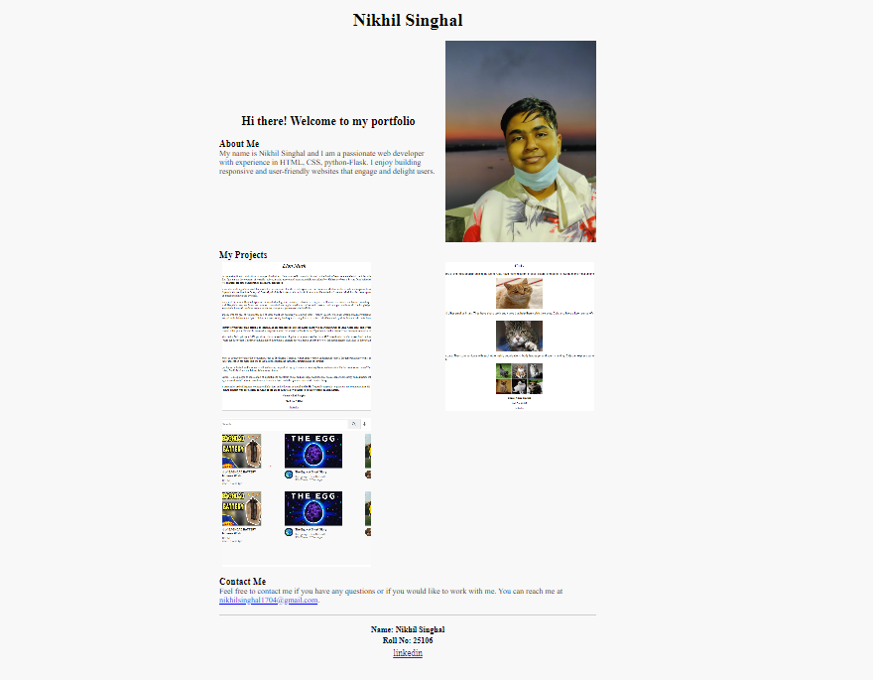**Screen Shot:**

**Practical – 9**

**Aim – Music Player**

**HTML Code:**

<!DOCTYPE html>

<html lang="en">

  <head>

    <meta charset="UTF-8" />

    <meta http-equiv="X-UA-Compatible" content="IE=edge" />

    <meta name="viewport" content="width=device-width, initial-scale=1.0" />

    <link rel="stylesheet" href="style.css" />

    <title>EG</title>

  </head>

  <body>

    <div class="main">

      <div class="sidebar">

        <div class="bhaisab">

          <div class="image-container">

            <img

              src="https://static.vecteezy.com/system/resources/previews/020/647/520/original/pig-face-icon-cute-animal-icon-in-circle-png.png"

              alt="bhaisab"

            />

            <div class="caption">

              <h5>Bhaisab</h5>

              <p>Bhaisab@gmail.com</p>

            </div>

          </div>

        </div>

        <div class="nav">

          <div class="nav1">

            <div class="button">

              <img

                src="https://e7.pngegg.com/pngimages/98/702/png-clipart-font-awesome-computer-icons-house-icon-design-house-angle-logo-thumbnail.png"

                alt="Home"

              />

              <h4>Home</h4>

            </div>

            <div class="button">

              <img src="search-engine.png" alt="Browse" />

              <h4>Browse</h4>

            </div>

            <div class="button">

              <img src="album.png" alt="Album" />

              <h4>Album</h4>

            </div>

            <div class="button">

              <img src="artist.png" alt="Artist" />

              <h4>Artist</h4>

            </div>

            <div class="button">

              <img src="video-camera.png" alt="Videos" />

              <h4>Videos</h4>

            </div>

          </div>

          <h3>MY MUSIC</h3>

          <div class="nav2">

            <div class="button">

              <img src="refresh.png" alt="Recently Played" />

              <h4>Recently Played</h4>

            </div>

            <div class="button">

              <img src="google-docs.png" alt="Local files" />

              <h4>Local Files</h4>

            </div>

          </div>

        </div>

        <div class="thingy">

          <img src="smartphones.png" alt="phone" />

          <div class="lines">

            <h5>Thingy</h5>

            <p>v.1.25</p>

          </div>

        </div>

      </div>

      <div class="container">

        <div class="head">

          <div class="search-bar">

            <img src="magnifying-glass.png" alt="search icon" />

            <input type="text" placeholder="Search for song, artist, etc" />

          </div>

          <div class="icons">

            <img src="bell.png" alt="Bell" />

            <img

              src="https://cdn-icons-png.flaticon.com/128/10542/10542430.png"

              alt="Settings"

            />

            <div class="loot">

              <p>Upgrade Plan</p>

            </div>

          </div>

        </div>

        <div class="topchart">

          <div class="heading">

            <h3>Billboard Topchart</h3>

          </div>

          <div class="content">

            <div class="covers">

              <img

                src="https://www.billboard.com/wp-content/uploads/2022/03/50.-Taylor-Swift-%E2%80%981989-2014-album-art-billboard-1240.jpg?w=600"

                alt=""

                width="150px"

                height="150px"

              />

              <img

                src="https://www.billboard.com/wp-content/uploads/2022/03/50.-Taylor-Swift-%E2%80%981989-2014-album-art-billboard-1240.jpg?w=600"

                alt=""

                width="150px"

                height="150px"

              />

              <img

                src="https://www.billboard.com/wp-content/uploads/2022/03/50.-Taylor-Swift-%E2%80%981989-2014-album-art-billboard-1240.jpg?w=600"

                alt=""

                width="150px"

                height="150px"

              />

              <img

                src="https://www.billboard.com/wp-content/uploads/2022/03/50.-Taylor-Swift-%E2%80%981989-2014-album-art-billboard-1240.jpg?w=600"

                alt=""

                width="150px"

                height="150px"

              />

            </div>

            <div class="description">

              <article class="abt">

                <h5>Blank Space</h5>

                <p>Taylor Swift</p>

              </article>

              <article class="abt">

                <h5>Blank Space</h5>

                <p>Taylor Swift</p>

              </article>

              <article class="abt">

                <h5>Blank Space</h5>

                <p>Taylor Swift</p>

              </article>

              <article class="abt">

                <h5>Blank Space</h5>

                <p>Taylor Swift</p>

              </article>

            </div>

          </div>

        </div>

        <div class="bottom">

          <div class="music">

            <article class="abt">

              <h3>Most Popular</h3>

              <p>92 Songs</p>

            </article>

            <div class="item">

              <div style="display: inline-flex; align-items: center">

                <p style="display: inline">01</p>

                <img

                  src="https://www.billboard.com/wp-content/uploads/2022/03/50.-Taylor-Swift-%E2%80%981989-2014-album-art-billboard-1240.jpg?w=40"

                  alt=""

                />

                <img

                  src="https://external-content.duckduckgo.com/iu/?u=http%3A%2F%2Fclipartmag.com%2Fimages%2Fyoutube-play-button-png-18.png&f=1&nofb=1&ipt=ec4d97ce55c47157d18d7fc677da0605ed78b9d2c49fa00a18c2491293f83d9b&ipo=images"

                  width="40px"

                />

                <p style="display: inline">Blank Space  </p>

              </div>

              <p style="display: inline">Taylor Swift  </p>

              <p style="display: inline">4:33</p>

              <img

                src="https://external-content.duckduckgo.com/iu/?u=https%3A%2F%2Fpurepng.com%2Fpublic%2Fuploads%2Flarge%2Fpurepng.com-red-heartheartoxygen-and-nutrientshumanclipartlove-1421526551807b8c9n.png&f=1&nofb=1&ipt=48e8e327002a11b1d27d39deeb9616ce333d45f154d54790c8c22c2ac31a6049&ipo=images"

                width="20px"

              />

            </div>

            <div class="item">

              <div style="display: inline-flex; align-items: center">

                <p style="display: inline">02</p>

                <img

                  src="https://www.billboard.com/wp-content/uploads/2022/03/50.-Taylor-Swift-%E2%80%981989-2014-album-art-billboard-1240.jpg?w=40"

                  alt=""

                />

                <img

                  src="https://external-content.duckduckgo.com/iu/?u=http%3A%2F%2Fclipartmag.com%2Fimages%2Fyoutube-play-button-png-18.png&f=1&nofb=1&ipt=ec4d97ce55c47157d18d7fc677da0605ed78b9d2c49fa00a18c2491293f83d9b&ipo=images"

                  width="40px"

                />

                <p style="display: inline">Blank Space  </p>

              </div>

              <p style="display: inline">Taylor Swift  </p>

              <p style="display: inline">4:33</p>

              <img

                src="https://external-content.duckduckgo.com/iu/?u=https%3A%2F%2Fpurepng.com%2Fpublic%2Fuploads%2Flarge%2Fpurepng.com-red-heartheartoxygen-and-nutrientshumanclipartlove-1421526551807b8c9n.png&f=1&nofb=1&ipt=48e8e327002a11b1d27d39deeb9616ce333d45f154d54790c8c22c2ac31a6049&ipo=images"

                width="20px"

              />

            </div>

            <div class="item">

              <div style="display: inline-flex; align-items: center">

                <p style="display: inline">03</p>

                <img

                  src="https://www.billboard.com/wp-content/uploads/2022/03/50.-Taylor-Swift-%E2%80%981989-2014-album-art-billboard-1240.jpg?w=40"

                  alt=""

                />

                <img

                  src="https://external-content.duckduckgo.com/iu/?u=http%3A%2F%2Fclipartmag.com%2Fimages%2Fyoutube-play-button-png-18.png&f=1&nofb=1&ipt=ec4d97ce55c47157d18d7fc677da0605ed78b9d2c49fa00a18c2491293f83d9b&ipo=images"

                  width="40px"

                />

                <p style="display: inline">Blank Space  </p>

              </div>

              <p style="display: inline">Taylor Swift  </p>

              <p style="display: inline">4:33</p>

              <img

                src="https://external-content.duckduckgo.com/iu/?u=https%3A%2F%2Fpurepng.com%2Fpublic%2Fuploads%2Flarge%2Fpurepng.com-red-heartheartoxygen-and-nutrientshumanclipartlove-1421526551807b8c9n.png&f=1&nofb=1&ipt=48e8e327002a11b1d27d39deeb9616ce333d45f154d54790c8c22c2ac31a6049&ipo=images"

                width="20px"

              />

            </div>

            <div class="item">

              <div style="display: inline-flex; align-items: center">

                <p style="display: inline">04</p>

                <img

                  src="https://www.billboard.com/wp-content/uploads/2022/03/50.-Taylor-Swift-%E2%80%981989-2014-album-art-billboard-1240.jpg?w=40"

                  alt=""

                />

                <img

                  src="https://external-content.duckduckgo.com/iu/?u=http%3A%2F%2Fclipartmag.com%2Fimages%2Fyoutube-play-button-png-18.png&f=1&nofb=1&ipt=ec4d97ce55c47157d18d7fc677da0605ed78b9d2c49fa00a18c2491293f83d9b&ipo=images"

                  width="40px"

                />

                <p style="display: inline">Blank Space  </p>

              </div>

              <p style="display: inline">Taylor Swift  </p>

              <p style="display: inline">4:33</p>

              <img

                src="https://external-content.duckduckgo.com/iu/?u=https%3A%2F%2Fpurepng.com%2Fpublic%2Fuploads%2Flarge%2Fpurepng.com-red-heartheartoxygen-and-nutrientshumanclipartlove-1421526551807b8c9n.png&f=1&nofb=1&ipt=48e8e327002a11b1d27d39deeb9616ce333d45f154d54790c8c22c2ac31a6049&ipo=images"

                width="20px"

              />

            </div>

            <div class="item">

              <div style="display: inline-flex; align-items: center">

                <p style="display: inline">05</p>

                <img

                  src="https://www.billboard.com/wp-content/uploads/2022/03/50.-Taylor-Swift-%E2%80%981989-2014-album-art-billboard-1240.jpg?w=40"

                  alt=""

                />

                <img

                  src="https://external-content.duckduckgo.com/iu/?u=http%3A%2F%2Fclipartmag.com%2Fimages%2Fyoutube-play-button-png-18.png&f=1&nofb=1&ipt=ec4d97ce55c47157d18d7fc677da0605ed78b9d2c49fa00a18c2491293f83d9b&ipo=images"

                  width="40px"

                />

                <p style="display: inline">Blank Space  </p>

              </div>

              <p style="display: inline">Taylor Swift  </p>

              <p style="display: inline">4:33</p>

              <img

                src="https://external-content.duckduckgo.com/iu/?u=https%3A%2F%2Fpurepng.com%2Fpublic%2Fuploads%2Flarge%2Fpurepng.com-red-heartheartoxygen-and-nutrientshumanclipartlove-1421526551807b8c9n.png&f=1&nofb=1&ipt=48e8e327002a11b1d27d39deeb9616ce333d45f154d54790c8c22c2ac31a6049&ipo=images"

                width="20px"

              />

            </div>

            <div class="item">

              <div style="display: inline-flex; align-items: center">

                <p style="display: inline">06</p>

                <img

                  src="https://www.billboard.com/wp-content/uploads/2022/03/50.-Taylor-Swift-%E2%80%981989-2014-album-art-billboard-1240.jpg?w=40"

                  alt=""

                />

                <img

                  src="https://external-content.duckduckgo.com/iu/?u=http%3A%2F%2Fclipartmag.com%2Fimages%2Fyoutube-play-button-png-18.png&f=1&nofb=1&ipt=ec4d97ce55c47157d18d7fc677da0605ed78b9d2c49fa00a18c2491293f83d9b&ipo=images"

                  width="40px"

                />

                <p style="display: inline">Blank Space  </p>

              </div>

              <p style="display: inline">Taylor Swift  </p>

              <p style="display: inline">4:33</p>

              <img

                src="https://external-content.duckduckgo.com/iu/?u=https%3A%2F%2Fpurepng.com%2Fpublic%2Fuploads%2Flarge%2Fpurepng.com-red-heartheartoxygen-and-nutrientshumanclipartlove-1421526551807b8c9n.png&f=1&nofb=1&ipt=48e8e327002a11b1d27d39deeb9616ce333d45f154d54790c8c22c2ac31a6049&ipo=images"

                width="20px"

              />

            </div>

          </div>

          <div class="Now">

            <article class="abt">

              <h3>Now Playing</h3>

              <p>56 down on the list</p>

            </article>

            <div class="boxy">

              <div class="upper">

                <img

                  src="https://www.billboard.com/wp-content/uploads/2022/03/50.-Taylor-Swift-%E2%80%981989-2014-album-art-billboard-1240.jpg?w=40"

                  alt="music image"

                />

                <h4>Blank Space</h4>

                <p>Taylor Swift</p>

                <div class="progress-bar"></div>

              </div>

              <div class="lower">

                <button>

                  <img

                    src="shuffle.png"

                    alt="Shuffle"

                  />

                </button>

                <button>

                  <img

                    src="rewind-button.png"

                    alt="previous"

                  />

                </button>

                <button>

                  <img

                    src="play-buttton.png"

                    alt="Play"

                  />

                </button>

                <button>

                  <img

                    src="forward.png"

                    alt="Forward"

                  />

                </button>

                <button>

                  <img

                    src="loop.png"

                    alt="loop"

                  />

                </button>

              </div>

            </div>

          </div>

        </div>

      </div>

    </div>

  </body>

</html>

**CSS Code:**

body {

    background-color: #f2f2f2;

    display: flex;

    overflow: hidden;

    justify-content: center;

    align-items: center;

    overflow: scroll;

    font-family: sans-serif;

}

.main {

    width: 160vh;

    height: 120vh;

    background-color: rgb(246, 252, 253);

    border-radius: 10px;

    box-shadow: 0px 0px 10px 1px rgba(105, 105, 105, 0.3);

    margin: 50px auto;

    display: flex;

    justify-content: center;

    align-items: center;

    z-index: 1;

}

.main .sidebar {

    display: flex;

    flex-direction: column;

    background-color: white;

    height: 100%;

    width: 20%;

    overflow: hidden;

    justify-content: flex-start;

    align-items: center;

    border-radius: 10px 0 0 10px;

}

.main .sidebar .bhaisab {

    display: flex;

    flex-direction: column;

    justify-content: center;

    padding: 25px 0px;

    overflow: hidden;

    margin-bottom: 20px;

}

.main .sidebar .bhaisab .image-container {

    display: flex;

    flex-direction: column;

    justify-content: center;

    align-items: center;

}

.main .sidebar .bhaisab .image-container img {

    display: block;

    box-shadow: 1px 2px 4px 6px rgb(213, 212, 212);

    border-radius: 50%;

    width: 70px;

    height: 70px;

}

.main .sidebar .bhaisab .caption {

    text-align: center;

    color: hwb(264 0% 98%);

    width: 100%;

    height: 30px;

    margin-top: 10px;

}

.main .sidebar .bhaisab .caption h5 {

    margin: 0;

    font-size: 1em;

}

.main .sidebar .bhaisab .caption p {

    margin: 0;

    color: rgba(112, 117, 120, 0.938);

    font-size: 0.8em;

}

.main .sidebar .nav {

    align-self: flex-start;

    display: flex;

    padding: 20px 25px;

    flex-direction: column;

    justify-content: space-between;

    overflow: hidden;

    margin-top: 20px;

}

.main .sidebar .nav h3 {

    padding: 5px 10px;

    color: rgba(167, 171, 172, 0.938);

    font-size: 0.8em;

    text-align: left;

}

.main .sidebar .nav1 {

    display: flex;

    flex-direction: column;

    justify-content: space-between;

    height: 25vh;

}

.main .sidebar .nav1 .button {

    display: flex;

    align-items: center;

    cursor: pointer;

    height: 30px;

}

.main .sidebar .nav .nav1 img {

    padding: 10px 10px;

    height: 20px;

    width: 20px;

}

.main .sidebar .nav .nav1 .h4 {

    margin: 0;

    color: rgba(0, 6, 7, 0.938);

    font-size: 0.8em;

}

.main .sidebar .nav2 {

    display: flex;

    flex-direction: column;

    justify-content: space-between;

    height: 9vh;

}

.main .sidebar .nav2 .button {

    display: flex;

    align-items: center;

    cursor: pointer;

    height: 30px;

}

.main .sidebar .nav .nav2 img {

    padding: 10px 10px;

    height: 20px;

    width: 20px;

}

.main .sidebar .nav .nav2 .h4 {

    margin: 0;

    color: rgba(0, 6, 7, 0.938);

    font-size: 0.8em;

}

.main .sidebar .thingy {

    margin-top: auto;

    margin-bottom: 20px;

    width: 80%;

    height: 60px;

    background: linear-gradient(135deg, #daeef6 0%, #daeef6 100%);

    border-radius: 5px;

    box-shadow: 0px 0px 10px 1px rgba(148, 143, 143, 0.3);

    display: flex;

    align-items: center;

    overflow: hidden;

}

.main .sidebar .thingy img {

    padding-left: 8px;

    height: 46px;

    width: 44px;

    margin-right: 10px;

}

.main .sidebar .thingy .lines {

    display: flex;

    flex-direction: column;

    justify-content: center;

}

.main .sidebar .thingy .lines h5 {

    margin: 0;

    font-size: 1em;

    color: #0b0101;

}

.main .sidebar .thingy .lines p {

    margin: 0;

    font-size: 1em;

    color: #afa4a4;

}

.main .container {

    display: flex;

    /* background-color: rgb(219, 229, 233); */

    flex-direction: column;

    justify-content: space-around;

    height: 100%;

    width: 80%;

    overflow: hidden;

}

.main .container .head {

    display: flex;

    padding: 10px;

    justify-content: space-between;

    align-items: center;

    height: 5%;

    overflow: hidden;

}

.head .search-bar {

    display: flex;

    align-items: center;

    border: 1px solid grey;

    border-radius: 20px;

    width: 30%;

    padding: 5px;

}

.head .search-bar img {

    padding-left: 5px;

    height: 20px;

    width: 20px;

    cursor: pointer;

}

.head .search-bar input[type="text"] {

    border: none;

    background-color: rgb(246, 252, 253);

    outline: none;

    padding: 5px;

    margin-left: 5px;

    width: 100%;

    font-size: 14px;

    color: grey;

    border-radius: 0px 20px 20px 0px;

}

.head .icons {

    display: flex;

    justify-content: space-evenly;

    align-items: center;

    width: 25%;

}

.head .icons img {

    height: 20px;

    width: 20px;

    cursor: pointer;

}

.head .icons .loot {

    display: flex;

    justify-content: center;

    align-items: center;

    background-color: red;

    box-shadow: 1px 1px 1px 1px rgb(65, 10, 10);

    border: 1px rgb(63, 9, 9);

    border-radius: 20px;

    height: 20px;

    width: 100px;

    padding: 5px;

    cursor: pointer;

}

.head .icons .loot p {

    color: white;

}

.main .container .topchart {

    position: relative;

}

.topchart .heading {

    display: flex;

    justify-content: space-between;

    align-items: center;

}

.topchart .heading p {

    color: #00000090;

}

.topchart .content {

    display: flex;

    flex-direction: column;

}

.topchart .content .covers {

    display: flex;

    justify-content: space-evenly;

}

.topchart .content .covers img {

    box-shadow: 10px 10px 10px 10px rgb(182, 182, 182);

    border-radius: 12px;

    margin: 0px -10px;

    cursor: pointer;

}

.topchart .content .description {

    display: flex;

    justify-content: space-evenly;

}

.topchart .content .description .abt {

    margin-right: 50px;

}

.topchart .content .description .abt h5 {

    margin-bottom: -10px;

}

.topchart .content .description .abt p {

    font-size: 11px;

    font-weight: bold;

    color: #00000090;

}

.main .container .bottom {

    display: flex;

    justify-content: space-around;

    height: 65%;

    overflow: hidden;

}

.container .bottom .music {

    padding: 20px;

    border: solid 2p black;

    width: 60vh;

}

.container .bottom .music .item {

    box-shadow: 4px 4px 4px 4px rgb(223, 223, 223);

    background-color: white;

    border-radius: 5px;

    height: 15%;

    margin: 10px 0;

    display: flex;

    align-items: center;

    font-size: 1rem;

    justify-content: space-between;

    padding: 0 10px;

}

.container .bottom .music .title1 {

    display: flex;

    flex-direction: column;

    justify-content: center;

}

.container .bottom .music .abt h3 {

    margin: 0px;

}

.container .bottom .music .abt p {

    font-size: 15px;

    margin-top: 5px;

    font-weight: bold;

    color: #57535390;

}

.main .container .bottom .Now {

    display: flex;

    flex-direction: column;

    width: 50vh;

    padding-left: 10px;

}

.main .container .bottom .Now .abt {

    height: 10%;

    padding: 20px

}

.main .container .bottom .Now .abt h3 {

    margin: 0;

}

.main .container .bottom .Now .abt p {

    font-size: 15px;

    margin-top: 5px;

    font-weight: bold;

    color: #57535390;

}

.main .container .bottom .Now .boxy {

    display: flex;

    flex-direction: column;

    border-radius: 10px;

    justify-content: space-between;

    background-color: white;

    align-items: center;

    overflow: hidden;

}

.boxy .upper {

    display: flex;

    flex-direction: column;

    justify-content: center;

    align-items: center;

    border-radius: 10px;

    padding: 10px;

}

.boxy .upper img {

    width: 200px;

    height: 200px;

    box-shadow: 4px 6px 6px 4px grey;

    object-fit: cover;

    border-radius: 50%;

}

.boxy .upper h4 {

    margin: 10px 0 5px 0;

    font-size: 20px;

    font-weight: bold;

    color: #555;

    text-align: center;

}

.boxy .upper p {

    margin: 0;

    font-size: 16px;

    color: #888;

    text-align: center;

}

.boxy .progress-bar {

    width: 100%;

    height: 8px;

    background-color: #d3d3d3;

    margin: 10px 0px;

    border-radius: 20px;

    overflow: hidden;

}

.boxy .progress-bar::before {

    content: "";

    display: block;

    width: 50%;

    height: 100%;

    background-color: blue;

    border-radius: 20px;

}

.boxy .lower {

    display: flex;

    justify-content: space-around;

    align-items: center;

    width: 100%;

    height: 40%;

    overflow: hidden;

    background-color: #f5f5f5;

    border-radius: 10px;

    margin-bottom: 10px;

}

.boxy .lower button {

    display: flex;

    justify-content: center;

    align-items: center;

    background-color: transparent;

    border: none;

    outline: none;

    cursor: pointer;

    margin: 10px;

}

.boxy .lower button img {

    width: 20px;

    height: 20px;

}

**Screen Shot:**

